**How To Mitigate Losing Trades Effectively**

About orderblocks

If you lose on the initial trade, then take 50% off the risk the next trade in the same trade idea

As a beginner, if you took a loss, just try to go back to BE and take it off. Especially if its the end of the week, take it off and regroup and end the week at BE or atleast trail the stop loss

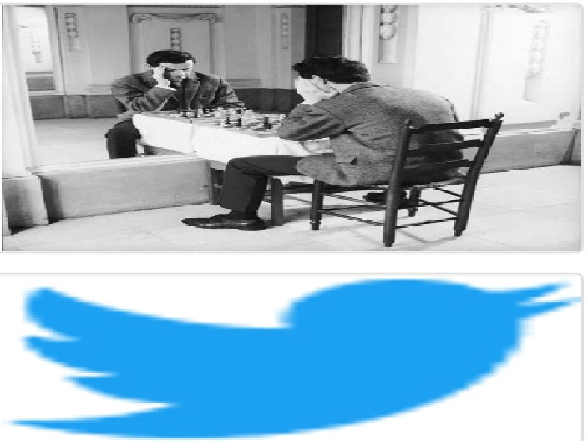Arjo I Twitter, lnstagram I Linktree

Linktree. Make your link do more.

, https://t.co/HhmmTN1fUI

JavaScript is not available.

***'!I*** https://twitter.com/arjoio